UNIT
Adopt-A-Drifter Program

LESSON 2
Climographs

Subject (Focus/Topic): Ocean and Atmospheric Science: Ocean Surface Currents and Climate

Grade Level: 5th – 9th grade

Average Learning Time: 2 50-minute classes

Lesson Summary (Overview/Purpose): Students will construct climographs for three coastal cities, (Arica, Chile, Trondheim, Norway, and Tokyo, Japan), by recording monthly average precipitation and temperature data. Students will use the climographs in order to make inferences about the climate and to determine whether relationships exist between the temperature or direction of ocean currents and coastal climate.

Overall Concept (Big Idea/Essential Question): Do ocean surface currents influence climate, and if so, how do they affect it?

Specific Concepts (Key Concepts):
- Climate can be defined as the long-term behavior of weather over time, including the average and extreme conditions for a region.
- Weather can be defined as the specific conditions of the atmosphere at a particular time and place.
- Surface currents affect climate by moving cold and warm water around the globe. In general, currents carry warm water from the tropics toward the poles and bring cold water back toward the equator.
- A surface current warms or cools the air above it, influencing the climate of the land near the coast.
- Winds pick up moisture as they blow across warm water currents. This often brings mild rainy weather to the coastal regions.
- Cold water currents cool the air above them and since cold air has less of an ability to hold moisture than warm air, these currents tend to bring cool, dry weather to adjacent land areas.
- Fog is often found along the land-sea borders where cold ocean currents exist. An example is the west coast of South America where fog is found off the coast and the driest desert in the world, the Atacama, exists!
- A climograph is a special type of graph that displays the monthly average precipitation and temperature for an area over the course of a year.
- By studying climographs, you can see how precipitation and temperature differ from one community to another.

Focus Questions (Specific Questions):
- What is climate? How does it differ from weather?
- What kind of water (warm or cold) is typically carried by surface currents from the tropics to the poles?
- What kind of water (warm or cold) is typically carried by surface currents from the poles to the tropics?
- What kind of weather would you expect to find in coastal regions along warm ocean currents? Why?
- What kind of weather would you expect to find in coastal regions along cold ocean currents? Why?

Objectives/Learning Goals:
- Students will construct climographs for three coastal cities.
- Students will describe how ocean surface currents affect climate on land.

Background Information:

The earth receives radiation from the sun. Because of the tilt of Earth’s axis, its rotation, and its revolution around the sun, there is an uneven heating of the surface of the earth, which causes convection currents, which give rise to global wind patterns. These persistent patterns, also known as wind belts, cause movements of ocean water called surface currents.

Ocean surface currents move in circular patterns, following the major wind belts. They are affected by the rotation of the earth, (Coriolis Effect), the presence of landmasses, and the shape of the seafloor.

The presence of solar energy drives interactions between the ocean and the atmosphere. Warm currents transfer heat to the surrounding atmosphere, and as winds blow, the warmer air picks up moisture through evaporation, which typically brings mild, rainy conditions to adjacent coastal areas, such as those in the Caribbean and Gulf of Mexico regions. Cold surface currents cool the surrounding atmosphere, and since water does not evaporate the same way in cooler air as it does in warmer air, they bring drier conditions to adjacent coastal areas, such as those in California and Morocco.

Because of the atmosphere’s and ocean’s role in distributing warm or cold air and moisture, they have a significant influence on weather and climate, despite a location’s latitude. Therefore, ocean surface currents affect climate.

Common Misconceptions/Preconceptions:
- Cities that are located farther from the equator, such as Tokyo, will generally experience colder temperatures throughout most of the year than cities that are located within tropical regions, such as Arica, Chile.

Materials:
- Blank Climographs (3 per student or group)
- Major Ocean Currents worksheet (provided below)
- Fact Sheet A with climate data for each location (provided below)
- Fact Sheet B with descriptions of coastal climates (provided below)

Technical Requirements:
- Access to a computer to show PowerPoint presentation.

Teacher Preparation:
- Provide students with copies of the blank climographs, Major Ocean Currents worksheet, and Fact Sheets A and B.
- Prepare PowerPoint presentation for viewing.
- Provide students with Wrap-Up questions (can be written on board).

Keywords:
- Climate
- Weather
- Solar radiation
- Wind
- Ocean surface currents
- Climograph
- Gulf Stream
- Gyre

Pre-assessment Strategy/Anticipatory Set:
- Ask students to define “climate”.
- Ask students to define “weather,” and to explain how we distinguish between climate and weather.
- Ask students to define “ocean surface current,” and explain how they are formed (by wind). Ask students if they know of any ocean currents, such as the Gulf Stream, and if they can point them out on a map.
- Present the question, “Do ocean surface currents influence climate?”
- Have students turn-and-talk with a partner about whether they think that ocean currents affect climate.
- Have partners write a hypothesis based on their discussion.
- Have students share their hypotheses with the class.

Lesson Procedure:
- Share the Specific Concepts (from above) with students by showing the “Ocean Surface Currents and Climate” PowerPoint presentation.
- Distribute a copy of the Major Ocean Currents worksheet to each student or group.
- Have students look at the map and write a prediction describing the climate they would expect of each place listed.
- Have students share their predictions.
- Distribute three blank climograph sheets and a copy of Fact Sheet A to each student or group.
- Using the climate data from Fact Sheet A, have students create a climograph for each city listed. Have students create a line graph for temperature and a bar graph for precipitation on the same sheet.

Wrap-up:
Once students create their climographs, students should write the answers to the following questions independently, on a separate sheet of paper. After writing their answers, if time allows, they can discuss their ideas with the class.
- Examine your climographs. What is the difference between the highest and lowest temperatures in the climograph for each city?
- Which city is in a desert? How can you tell?
- Take a closer look at the Arica, Chile climograph. What can you tell about the seasons and the months? How is this related to the hemisphere where Arica is located?
- Is there a relationship between the temperature of the ocean current and the coastal climate?
- Is there a relationship between the direction of the ocean current and the coastal climate?
- In general, on which side of the ocean basins are the cold currents? Warm currents?
- What can you infer about the climate of each region by reviewing these climographs?

Wrap-Up Answers:
  - Trondheim: 32 Arica: 12 Tokyo: 39
  - Arica, Chile. Because it has no precipitation for the year.
  - It is warmer in January and February. The seasons in the southern hemisphere are opposite to the northern hemispheres. It is summertime in Arica during January and February.
  - Yes. Warm currents bring warm, moist air and cold currents bring cool, dry air to the region.
  - Yes. When the current is flowing away from the coast it will cause the air to be drier on land.
  - In general, the cold currents are on the eastern side of the ocean basins and warm currents are on the western side of the ocean basins.
  - Answers will vary. But you obviously see that Arica is a desert. Trondheim is warm compared to it latitude location. Tokyo is quite rainy.
They have mild temperatures because of the moderating effect of the ocean water.

After completing the questions, distribute a copy of Fact Sheet B to each student or group. Read the facts about the climate of each location aloud and discuss with the students.

Assessment and Evaluation:
Check each climograph to ensure that it aligns with the corresponding data. Collect the answers to the wrap-up questions and grade them based on their accuracy and correct use of scientific vocabulary and language.

Standards:
- National Science Education Standards Addressed (Grades 5-8):
NSES D: Earth and Space Science
Sub-category: Structure of the earth system
- Ocean Literacy Principles Addressed (Grades K-12):
Principle 3: The ocean is a major influence on weather and climate.
Fundamental Concepts: a, b, d
- Atmospheric Science Literacy Principles Addressed:
Essential Principle 3: Atmosphere circulations transport matter and energy.
Fundamental Concept: 3.2, 3.4, 3.5
Essential Principle 4: Earth’s atmosphere changes over time and space, giving rise to weather and climate.
Fundamental Concept: 4.3
Essential Principle 5: Earth’s atmosphere continuously interacts with the other components of the Earth System.
Fundamental Concept: 5.1
- Climate Literacy Principles Addressed:
Essential Principle 2: Climate is regulated by complex interactions among components of the earth system.
Fundamental Concepts: A, B
Essential Principle 4: Climate varies over space and time through both natural and man-made processes.
Fundamental Concepts: A, B
- State Science Standard(s) Addressed:
Will differ depending on your state
Additional Resources:
Websites:
Ocean Literacy Principles - http://www.coexploration.org/oceanliteracy/scopeandsequence/publicreview/index.html#cfds

Climate Literacy Principles – http://www.climate.noaa.gov/index.jsp?pg+/education/edu_index.jsp&edu=literacy

Atmospheric Science Literacy Principles – http://eo.ucar.edu/asl/

National Climatic Data Center (NCDC) – http://www.ncdc.noaa.gov/oa/ncdc.html

World Meteorological Organization (WMO) – http://www.wmo.int/pages/index_en.html

WMO Weather, Climate, and Water Science for Youth –http://www.wmo.int/youth/climate_en.html

IRI/LDEO Climate Data Library – http://iridl.ldeo.columbia.edu/

Author: Mary Cook
Reformatted and enhanced by Amanda Laurier

Creation date: July 2, 2010

Name ________________________________________________________________________________________

Major Ocean Currents

Look at the map of major ocean currents and write a prediction describing the climate you would expect of each place listed below. (The symbols are to help locate the cities on the world map.)

- Arica, Chile (along the Peru Current)

________________________________________________________________________

________________________________________________________________________

- Trondheim, Norway (along the Norwegian Current)

________________________________________________________________________

________________________________________________________________________

- Tokyo, Japan along the (Kuroshio Current)

________________________________________________________________________

________________________________________________________________________

Map of Major Ocean Currents
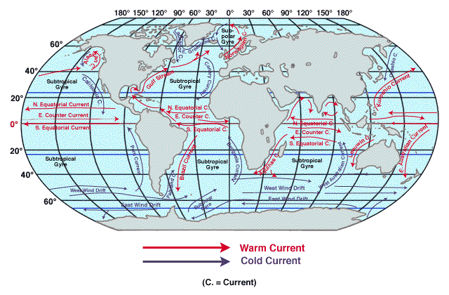
Name _________________________________________________________________

Using the climate data from Fact Sheet A, create a climograph for each city listed. Use a line graph for temperature and a bar graph for precipitation on the same graph.

 |  |  |  |  |  | Climograph
 |  |  |  | City: |  |  |  | Latitude Location:
 | 100 |  |  |  |  |  |  |  |  |  |  |  |  |  | 100
F | 95 |  |  |  |  |  |  |  |  |  |  |  |  |  | 95
 | 90 |  |  |  |  |  |  |  |  |  |  |  |  |  | 90
E | 85 |  |  |  |  |  |  |  |  |  |  |  |  |  | 85 | P
R | 80 |  |  |  |  |  |  |  |  |  |  |  |  |  | 80 | R
U | 75 |  |  |  |  |  |  |  |  |  |  |  |  |  | 75 | E
T | 70 |  |  |  |  |  |  |  |  |  |  |  |  |  | 70 | C
A | 65 |  |  |  |  |  |  |  |  |  |  |  |  |  | 65 | I
R | 60 |  |  |  |  |  |  |  |  |  |  |  |  |  | 60 | P
E | 55 |  |  |  |  |  |  |  |  |  |  |  |  |  | 55 | I
P | 50 |  |  |  |  |  |  |  |  |  |  |  |  |  | 50 | T
M | 45 |  |  |  |  |  |  |  |  |  |  |  |  |  | 45 | A
E | 40 |  |  |  |  |  |  |  |  |  |  |  |  |  | 40 | T
T | 35 |  |  |  |  |  |  |  |  |  |  |  |  |  | 35 | I
 | 30 |  |  |  |  |  |  |  |  |  |  |  |  |  | 30 | O
 | 25 |  |  |  |  |  |  |  |  |  |  |  |  |  | 25 | N
 | 20 |  |  |  |  |  |  |  |  |  |  |  |  |  | 20
 | 15 |  |  |  |  |  |  |  |  |  |  |  |  |  | 15
 | 10 |  |  |  |  |  |  |  |  |  |  |  |  |  | 10 | in
 | 5 |  |  |  |  |  |  |  |  |  |  |  |  |  | 5
 | 0 |  |  |  |  |  |  |  |  |  |  |  |  |  | 0
 |  | J | F | M | A | MY | JN | JL | AU | S | O | N | D
 |  |  |  |  |  | Months of the Year

Name _________________________________________________________________
Fact Sheet A (Climate Data)
Average Precipitation for Trondheim, Norway (inches)

Jan | Feb | Mar | Apr | May | Jun | Jul | Aug | Sep | Oct | Nov | Dec
2.1 | 1.6 | 2.8 | 2.0 | 1.8 | 2.7 | 3.0 | 3.5 | 3.5 | 2.5 | 3.0 | 5.5

Average Temperature for Trondheim, Norway (ºF)

Jan | Feb | Mar | Apr | May | Jun | Jul | Aug | Sep | Oct | Nov | Dec
25 | 27 | 32 | 39 | 46 | 54 | 57 | 57 | 50 | 43 | 34 | 30
______________________________________________________________________________________
Average Precipitation for Arica, Chile (inches)
Jan | Feb | Mar | Apr | May | Jun | Jul | Aug | Sep | Oct | Nov | Dec
0 | 0 | 0 | 0 | 0 | 0 | 0 | 0 | 0 | 0 | 0 | 0
Average Temperature for Arica, Chile (ºF)
Jan | Feb | Mar | Apr | May | Jun | Jul | Aug | Sep | Oct | Nov | Dec
74 | 74 | 73 | 69 | 66 | 63 | 62 | 62 | 63 | 65 | 68 | 71

______________________________________________________________________________________

Average Precipitation for Tokyo, Japan (inches)

Jan | Feb | Mar | Apr | May | Jun | Jul | Aug | Sep | Oct | Nov | Dec
2.0 | 2.8 | 4.2 | 5.1 | 5.7 | 6.9 | 5.3 | 5.8 | 8.5 | 7.6 | 3.8 | 2.1

Average Temperature for Tokyo, Japan (ºF)

Jan | Feb | Mar | Apr | May | Jun | Jul | Aug | Sep | Oct | Nov | Dec
42 | 43 | 48 | 57 | 65 | 71 | 77 | 81 | 74 | 64 | 55 | 47

Name ____________________________________________________________________

Fact Sheet B

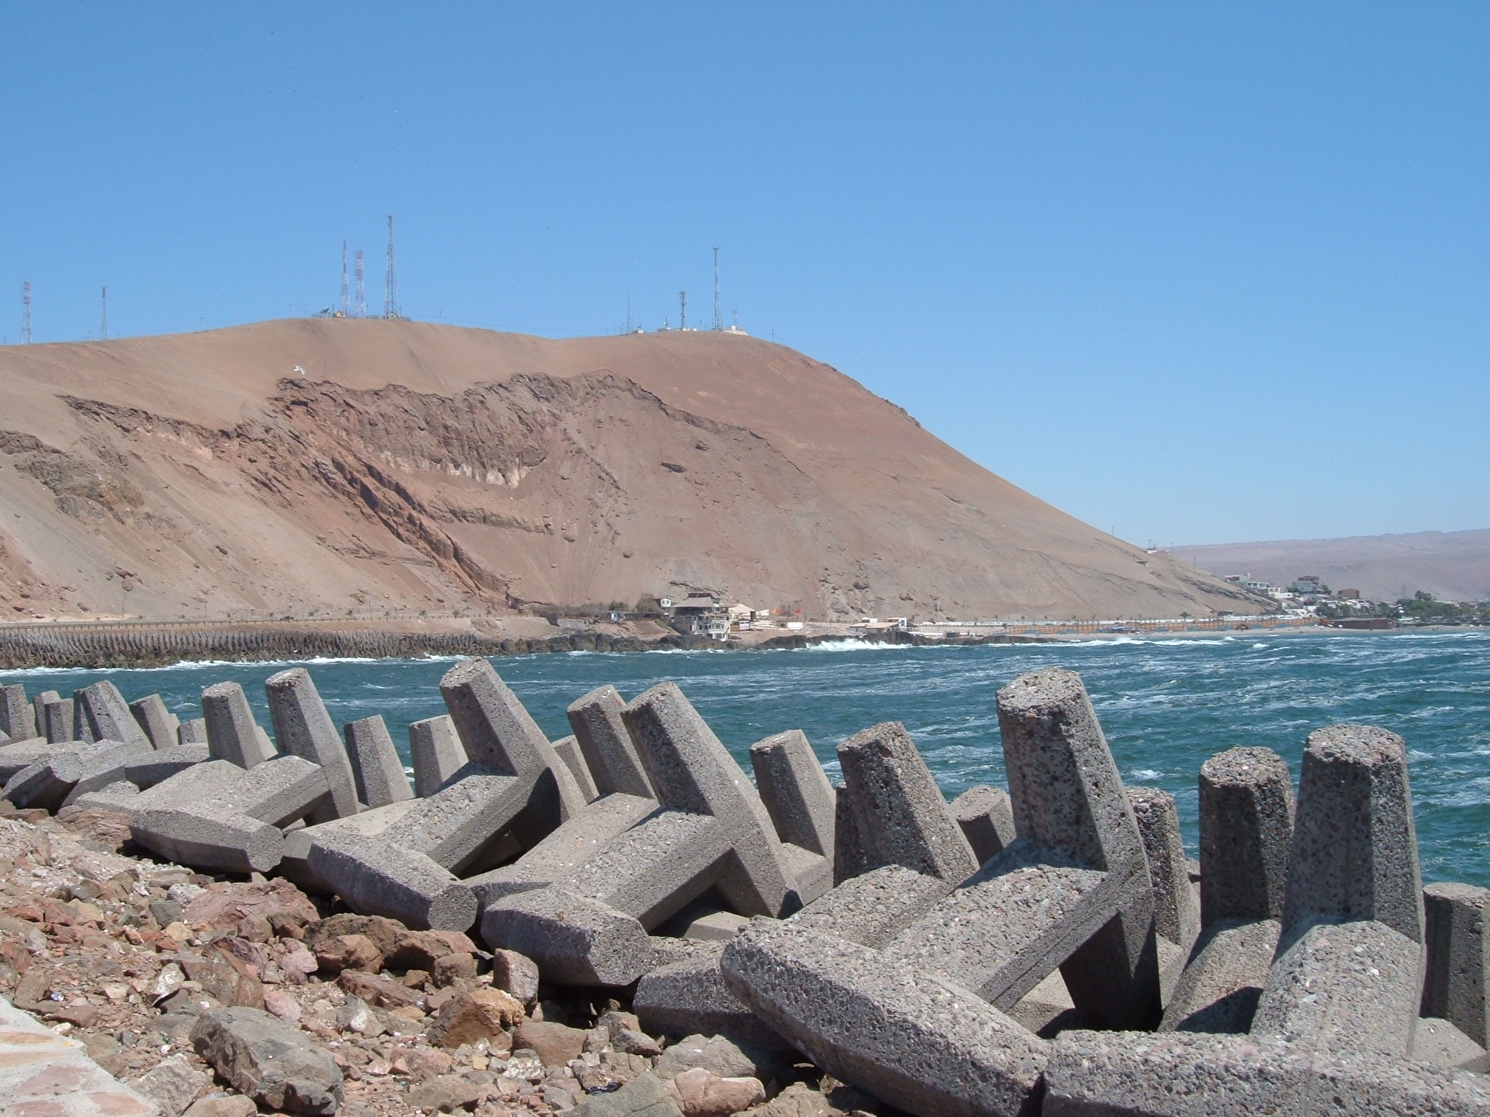 Arica, Chile (photo credit: Mary Cook)

Arica, Chile lies within one of the driest regions on Earth called the Atacama Desert. Ocean currents keep clouds and fog just off the coast, so most rain falls into the nearby ocean.

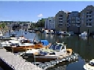 Trondheim, Norway (photo credit: www.cbnpa.rake.edu)

Trondheim, Norway has a temperate climate. Summers and winters are remarkably mild for their latitude. Rainfall is very heavy. The local harbors are free of ice most of the winter.

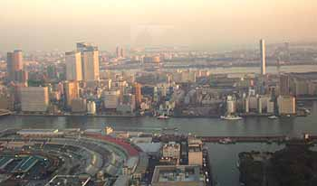 Tokyo, Japan

Tokyo, Japan has a rainy climate and the temperature is milder than one expects at that latitude.

